Subtitling Hong Kong Code-Mixing and Code-Switching: The case of Netflix English and Spanish official subtitles for Hongkonese audiovisual creations
Luis Damián Moreno García
Department of Translation, Interpreting and Intercultural Studies
Hong Kong Baptist University, Hong Kong
Correspondence: luismoreno@hkbu.edu.hk
ORCiD: 0000-0003-1046-8574
Peer review: This article has been subject to a double-anonymised review process.
Copyright notice: This article is issued under the terms of the Creative Commons Attribution License, which permits use and redistribution of the work provided that the original author and source are credited.
You must give appropriate credit (author attribution), provide a link to the license, and indicate if changes were made. You may do so in any reasonable manner, but not in any way that suggests the licensor endorses you or your use. You may not apply legal terms or technological measures that legally restrict others from doing anything the license permits.
https://creativecommons.org/licenses/by/4.0/
Abstract
Translation has largely been considered a process involving only two languages, source and target. However, plurilingual audiovisual content has proliferated over the last few decades, reflecting, as a result, the world’s linguistic intermingling. Such a plurality complicates both theoretical categorizations and translation practices. Even though multilingualism in the media has received scholarly attention, more explorations are needed to ascertain the translation processes and methods adopted to handle linguistically diverse source texts in the streaming era.
The present piece of research tentatively explores the treatment given to Cantonese and English code-mixing and code-switching present in Hongkonese films and TV shows currently streamed on Netflix, the video-on-demand platform. This article probes a selection of such content and compares the original dialogues with official Chinese, English and Spanish subtitles. Preliminary results point towards a loss of linguistic diversity and nuance caused by subtitling processes. The differentiated roles that both languages originally play in creating comedic, stylistic, or emphatic effects are rarely retained, possibly affecting viewers’ reception and appreciation. This article argues that further attention should be paid to the translation and adaptation of code-mixing and code-switching present in Hongkonese creations, both by the industry and academia, if such a multilingual reality is to be portrayed successfully via subtitles.
Keywords: Cantonese audiovisual content; Hong Kong audiovisual media; Netflix subtitles; multilingual subtitling; code-mixing and code-switching; multilingual translation strategies

Introduction
Over the course of history, consecutive waves of migratory events, alliances and conquests have merged and broken apart societies, creating mixed languages, pidgins, and creoles. Nowadays, different languages constantly exert influence on each other in a technologically connected world. Multilingualism can be defined as ‘the co-presence of two or more languages (in a society, text or individual)’ (Grutman, 2009: 182). This phenomenon has historically been greatly misunderstood, stigmatised as a potential threat. The concept of the monolingual nation has been essential as a legitimation and standardisation strategy (Gogolin, 2021) and signs of multilingualism in literature were first ‘associated with a flavour of treachery to the national literature’ (Meylaerts, 2013: 1301). Nevertheless, its status has drastically improved, being nowadays key part of country-level policies. Its presence has also reached most types of both traditional and digital media. However, we are still ‘not sufficiently aware of the importance and omnipresence of multilingualism’ (Meylaerts & Serban, 2014: 2), and it is only recently that the topic has started to gather significant scholarly attention.
This paper hones its focus on two of the manifestations of multilingualism, that of code-mixing and code-switching, in Hongkonese audiovisual creations. The Special Administrative Region of Hong Kong is a highly multilingual area, where the official languages of English and Chinese (Hong Kong Cantonese) coexist with other 24 minor languages (Bolton, et al., 2020). The most prevalent type of multilingualism in Hong Kong involves native Hong Kong speakers inserting English words and phrases to Cantonese sentence structures, where ‘Cantonese acts as the “matrix language”’ and ‘English acts as the “embedded language”’ (Setter, et al., 2010: 98). The inclusion of English elements into Cantonese grammar during code-mixing can be attributed to the historical background of Hong Kong as an English-speaking colony. The term code-mixing thus refers in this study to ‘intra- sentential alternation of Cantonese and English in Hong Kong’ (ibid: 96). In turn, the term code-switching refers to inter-sentential alternation of Cantonese and English, normally entire sentences. Code-switching can be defined as ‘the use of two languages at the same time in one situation’ (Appel & Muysken, 2006: 27) and plays varying roles according to each specific community of code mixers. Even though present, code-switching is not as prevalent as code-mixing among Hong Kong speakers (Chen, 2008).
These two features are commonly represented in Hong Kong’s audiovisual content through multilingual dialogue in mostly Cantonese, English and Mandarin Chinese. The present paper examines the treatment of code-mixing and code-switching present in several Hong Kong films and TV series on the Netflix platform.
Netflix, an audiovisual production company with presence over 190 countries (Netflix, 2022), is a key player in the official distribution of audiovisual content at a global scale. Multilingual subtitling, understood as the provision of subtitles in multiple languages for viewers who do not understand the original language of the film, is part of Netflix’s distribution strategy. During the last two decades, this platform has contributed to a boost of accessibility to niche content, some of it being multilingual. In recent years, Hongkongese audiovisual creations have reached foreign markets thanks to this over-the-top media service. However, the treatment given by Netflix to different types of multilingual scripts have not been explored. This paper investigates how Netflix's subtitling processes handle the complexity of code-mixing and code-switching in Hong Kong's multilingual content, focusing specifically on English and Spanish official Netflix subtitles, with the aim of bringing attention to the subtitling of code-mixing and code-switching dialogues.

Literature Review
The following literature review covers previous scholarly findings related to multilingualism in Hong Kong, then focusing on previous studies around the topic of translation strategies and multilingualism. Moreover, previous scholarly findings in relation to the topics of multilingualism and Netflix audiovisual products are also located and discussed.

Code-mixing and code-switching in Hong Kong
Multilingualism in Hong Kong has gone through a number of different stages. According to Bacon-Shone and Bolton, ‘from the late nineteenth century until the immediate postwar period, the dominant Chinese language in Hong Kong was the Cantonese vernacular’ (2008: 26), while from the 60s to the 90s there was the ‘rise of the modern Hong Kong Cantonese language’ (Ibid: 27), which is the main source language in this study. British colonialism has played a key role in the influence of the English language in the S.A.R. However, it was only after the 1970s that English spread broadly across society, alongside the emergence of the middle class, thanks to compulsory education policies (Bolton, et al., 2020).
According to 2016 data from the Population By-census by the Census and Statistics Department of the Hong Kong Special Administrative Region, 68.2% of the population aged over 5 years old could read English, 66.0% could write English and the numbers of those who could speak it went from 44.7% in 2006 to 53.2% in 2016 (HKSAR Gov, 2016). Moreover, the 2021 Population Census detected that more than 50% of Hong Kong people aged 5 and over was capable of speaking either English or Putonghua, and that ‘over 90% of persons aged 6-24 attending full-time courses in educational institutions in Hong Kong were able to read and write both Chinese and English’ (HKSAR Gov, 2022). The data show that knowledge of English has grown exponentially and that such language is nowadays still an essential part of secondary and tertiary education. Moreover, Hong Kong displays a distinctive use of the English language at the lexical, grammatical, and syntactical levels, as noticed by Bolton (2002, 2003), including unique accents, vocabulary, and grammar variations (Bolton, et al., 2020).
In terms of code-mixing in Hong Kong, it seems to be a strategy of neutrality, allowing Hongkonese people to neither ‘appear totally westernised’ nor ‘uncompromisingly Chinese in orientation’ (Gibbons, 1983: 145). Code-switching derives from the bilingualism of Hong Kong. Previous researchers have attested their presence in many different types of discourse, including print media (Yau, 1993), song lyrics (Chan, 2009), secondary education (Lixun, 2019) or the internet (Lee, 2007). In the case of films, Fan (2023) notices that code-mixing and code-switching have been part of Cantonese cinema since the 1930s up to the present time. However, multilingualism and code-mixing or code-switching have very different statuses in Hong Kong. While Hong Kong pushes a trilingual and biliterate policy, it discourages the presence of code-switching and code-mixing in classrooms, both from the part of students and teachers (Li, 2017, 2022). This distinction also seems clear in the case of official subtitles for the region, in either Chinese or English (Cheung, 2020).

Subtitling strategies for multilingualism
The topic of multilingualism and translation has been dealt extensively in Audiovisual Translation Studies (see Beseghi, 2017; de Higes-Andino, 2014; Meylaerts and Serban, 2014, to mention but a few). Retaining multilingualism through subtitles is a challenge exacerbated by the space and time constraints associated with subtitling. This section mainly focuses on translation strategies specifically aimed at dealing with multilingualism in subtitles.
Bartoll (2006) offered solutions in relation to the subtitling of multilingual films, proposing several techniques to deal with this phenomenon. These solutions originated from subtitles for the deaf and hard of hearing. These included the use of italics, ‘different colours or the paratextual information within brackets’ (Ibid: 1).
Baldo (2009) studied the subtitles of the multilingual TV series The Lives of the Saints (2004), which included code-switching between Italian and Canadian-English. The author contends that subtitling allows for better retention of multilingualism, as well as better conservation of the ideology behind the creation, when compared to dubbing. However, the author also recognises that ‘the decision to subtitle some dialogue while leaving other speeches untranslated often represents an ideological intervention’ (Ibid: 131), a decision that the subtitling team might not have the authority to make.
In the case of the English-to-Spanish subtitling of the multilingual film Inglorious Basterds (2009), which included English, German, French and Italian dialogues, the tendency in terms of subtitling strategies was ‘the deletion of linguistic elements’, the language switches being only perceivable ‘orally but not through written language’ (Ávila-Cabrera, 2013: 99).
Moreover, Corrius, Espasa and Zabalbeascoa explored the audio description of multilingual films, finding that ‘multilingualism can be rendered with a gamut of strategies, depending on the combination of verbal/non-verbal, visual and acoustic codes at stake’ (2019: 147). Corrius and Zabalbeascoa proposed the term L3 to refer to ‘forms of expression other than a text’s main language’ (2019: 72), as well as a number of detailed strategies for L1 and L3ST segments such as deletion, repetition and substitution, and the possible results of such operations (2011: 122-127).
Martínez-Sierra, Martí-Ferriol et al., (2010) analysed polyglot Spanish films, detecting the following translation strategies: self-translation, liaison interpreting, subtitling, and no-translation. In relation to multilingual diversity in Spanish immigration films, De Higes-Andino et al., (2013) offered both strategies and techniques for such a challenge, following Molina and Hurtado (2002). Strategies were twofold, to mark multilingualism or not, while techniques included normal font, italics, colours, intralinguistic subtitle, no-translation indicating language in brackets and no-translation, and were classified following a domestication-foreignization continuum. De Higes-Andino further covered the subtitling of multilingual films into Spanish (2014), proposing a model analysis for the study of multilingualism in film, composed of translation modes, strategies, constraints, and ideologies.
Szarkowska, Żbikowska and Krejtz (2013) proposed strategies specifically aimed at multilingualism in subtitles for the deaf and hard of hearing. These included vehicular matching, explicit attribution, colour coding and linguistic homogenisation. The authors believe that a more varied set of strategies, such as adding foreign languages to subtitles, might increase the retention of multilingualism.
After assessing a number of strategy classifications proposed by previous scholars, this article proposes a classification of strategies (see the Methodology section) to explore the English and Spanish Netflix subtitles for Hongkonese creations and determining how and to what extent they were used.

Netflix and multilingualism
Netflix has received attention from scholars of a plethora of backgrounds, including Media Studies, Film Studies, Second Language Acquisition and Translation Studies, to mention but a few. The study of its subtitling and dubbing practices has started to gather momentum in recent years specially in the field of Translation Studies (Lobato, 2019). For example, new research is appearing on the subfields of translation process (Pedersen, 2018), translation quality (Ponkala, 2018; Sánchez-Mompeán, 2021), and subtitle and dubbing consumption and reception (Ju, 2019; Kuosmanen, 2020; Kuscu-Ozbudak, 2021) in relation to Netflix content.
Ju (2019) explored the consumption of Korean dramas by US audiences by assessing user reviews in the platform, discovering an ‘emotional and transcultural engagement in K-dramas’ (p. 14), which was made possible and influenced by the subtitles provided by the platform. Kuosmanen (2020) focused on Finnish Netflix users and subtitles, detecting that users were ‘more satisfied with the service’s title selection that the quality of its subtitles’ (Ibid: 2), while Kuscu-Ozbudak (2021) explored the attitudes of Turkish millennials towards Netflix subtitles and translation policies, finding that viewers assume quality subtitles from the platform, and that ‘a decrease in subtitling quality may lead to cancellation of the subscription’ (Ibid: 1).
Previous studies point to subtitles as key enablers of translingual and transcultural consumption, while also drawing our attention towards subtitling quality. However, studies discussing multilingualism, code-mixing and/or code-switching in Netflix subtitles or dubs are scarce.
Jenner (2018) mentions that ‘despite the multilingualism of many Netflix texts, language can still be a hindrance to any “grammar of transnationalism”’ (Ibid: 231); that is to say, Netflix might foster domestication at the expense of multilingualism in order to make its content transnational. The author goes on to mention that Netflix mobilises translation to make ‘the domestication of texts or their integration into national media systems’ (Ibid: 237) possible, conceivably reducing the linguistic and cultural complexity of audiovisual creations.
From the field of Translation Studies, Labarta Postigo (2021) analysed the translation strategies used to deal with English idioms and idiomatic expressions appearing in different subtitles from comedy dramas and series offered by several providers, including Netflix. She detected a ‘reduction of figurative meaning in translated subtitles’ (Ibid: 15), in line with the general simplification caused by subtitles. Even though this study included a multilingual analysis and comparison between different languages, the focus was not on the multilingualism present in subtitles, but on a comparative analysis between monolingual subtitles.
Savoldelli and Spiteri Miggiani (2023) analysed the strategies and techniques used to deal with the multilingualism present in the Italian dub streams of five multilingual Netflix-produced shows. The authors concluded that the dubbing ‘ensured a degree of visibility to linguistic diversity in the dubbed versions, albeit not always consistent with that of the originals’, and that ‘Netflix’s directive to avoid dubbing over foreign language was not upheld consistently’, as ‘foreign languages were in fact occasionally dubbed over, particularly when code switching and code mixing occurred’ (Ibid: 20). Even though the topic of study is not subtitling, the results point to outstanding challenges when representing code-mixing or code-switching.
After thorough explorations, previous research on Cantonese-speaking audiovisual creations available on Netflix seems very scarce. Moreover, Cantonese as a source text for Spanish translations has not received extensive academic coverage up to the present, and, to the best knowledge of the researcher, there are no previous studies researching the translation of Cantonese content on Netflix into English or Spanish. All in all, too little is known about the translation strategies employed or the treatment applied to these linguistically diverse source texts.

Rationale and Methodology
The writing of this article was partially motivated by the attention that Netflix gathered after the viral reach of some of its exclusive titles, inadvertently bringing to light subtitling quality issues and indirect translation practices (Giustini, 2022). This piece tries to assess the treatment of multilingualism in the English and Spanish subtitles for Hongkonese creations. The main focus is the verbal codes of multilingualism (Voellmer, 2012) as part of TV series and film dialogues. Visual codes were only included if they were textual in nature (e.g., a billboard with printed text appearing on it). Furthermore, it analyses translation strategies to explore the constraints and processes that might affect the treatment of such multilingualism. Finally, it (re)proposes a series of strategies to increase multilingualism retention in subtitles.
As mentioned, the strategies and constraints detected by previous researchers were applied to the Netflix indirect subtitling scenario; that is, to the Cantonese-English-Spanish language trio. De Higes-Andino, Prats-Rodríguez et al., (2013) proposed two different strategies for the treatment of multilingualism: marking or non-marking. This key distinction will be employed to assess the level of multilingualism retention. Further subcategories inside the main categories were detected by the authors, which will also be partially used in this study. Moreover, following Martí-Ferriol (2010) and de Higes-Andino (2014), this study will briefly locate the linguistic constraints specific to the Cantonese context.
First, the Netflix platform was manually scraped in search of Hongkonese/Cantonese content. A combination of different keywords such as ‘Cantonese’, ‘Hongkonese’ or ‘from Hong Kong’, among others, were used to locate the maximum number of titles possible. As of January 2022, the number of Cantonese creations was 190, composed of four TV series and 186 films. The roster covered a period of 40 years, from 1981 to 2021 (Table 1). Cantonese content clearly shows a greater presence when compared with the 59 Cantonese titles detected in 2021 by Shi and Zhou (2021).
Table 1: Percentage of Hongkonese content on Netflix according to release year periods.
1980-1989 |  | 1990-1999 |  | 2000-2009 |  | 2010-2019 |  | 2020-present
40 | 21.05% | 80 | 42.1% | 29 | 15.26% | 38 | 20% | 3 | 1.57%
Over 60% of titles’ screening or airing date was 1999 or earlier, and fewer than 25% were from the year 2010 onwards, making it a slightly dated collection. From this total number, 49 titles offered Spanish subtitles, equivalent to 25% of all content. The presence of Spanish language variants (dubbing or subtitles), trying to adapt to different locales, such as Spanish for Spain or Spanish for Latin America, was detected in only four titles: Kung Fusion (2004), Time and Tide (2000), Ip Man (2008) and Ip Man 2 (2010). The distinction was limited to ‘Spanish’ (Español), presumably a neutral variant used for the Latin American market, and Spain’s Spanish (Español de España) for European Spanish.
In its Timed Text Style Guide: General Requirements, section 12, Translator Credits, Netflix requires the inclusion of ‘the translator credit as the last event of the subtitle file’ (Netflix Partner Help Center, 2023a). Therefore, the names of Spanish subtitlers were included in the TL subtitles (with a few exceptions that might derive from translators having ‘submitted a formal waiver of rights to be credited’). The method of indirect translation was easily detected in the case of most Spanish subtitles for Hongkonese creations by searching for information on the linguistic proficiency of the translators involved, either via common Google searches or by checking LinkedIn profiles. Therefore, English subtitles were included in the analysis so as to assess the indirect subtitling process. Preliminary findings showed that multilingualism in the form of code-mixing and code-switching was more prominent in newer creations over older ones, as well as in TV series over films. Thus, more recent films and TV series were considered as most relevant to the study. In order to include an updated portrayal of Hongkonese multilingualism, only films from the year 2000 onwards were chosen, specially from the year 2013. A total amount of 10 creations available at the time of study in Netflix UK were chosen due to their relevance, three TV series and seven films (see Table 2). Relevance was based on the amount of code-mixing and code-switching detected during the first 20 minutes of viewing.
Table 2: Hongkonese TV series and films chosen as case studies.
 | Original Title | English Title | Spanish Title | Year | Type
1 | 性敢中環 | Sexy Central (2 chapters) | Sexy Central | 2019 | TV series
2 | 家和萬事驚 | A Home with a View | Vista al Mar | 2019 | Film
3 | 衝上雲霄 | Triumph in the Skies | Triumph in the Skies | 2015 | Film
4 | 超級經理人 | The Midas Touch | The Midas Touch | 2013 | Film
5 | 順流逆流 | Time and Tide | Contra la Corriente | 2000 | Film
6 | 向西聞記 | Hong Kong West Side Stories (4 chapters) | Amores sin barreras en Hong Kong | 2018 | TV series
7 | 分手100次 | Break up 100 | Break up 100 | 2014 | Film
8 | 鐵探 | The Defected  (2 chapters) | Detective de Hierro | 2019 | TV series
9 | 單身男女2 | Don’t Go Breaking My Heart 2 | No me rompas el corazón 2 | 2014 | Film
10 | 失戀急讓 | Temporary Family | Temporary Family | 2014 | Film
Regarding the TV series data sample, it includes romance, comedy, and action. Sexy Central (2019) is a romance and friendship TV drama where five ‘young working women juggle work, love, sex and booze’ (Netflix HK-EN, 2023), Hong Kong West Side Stories (2018) is a comedic TV series which tells the loosely interconnected lives of young Hongkonese men and women, and The Defected (2019) is an action and crime TV drama which depicts the fight for power in the police force. In regard to films, the genres present are comedy, romantic drama, and thriller. The comedy A Home with a View (2019) portrays a disgruntled family whose dream home view is ruined by an unsightly billboard. Temporary Family (2014) is a comedic drama that depicts the lives of four unlikely roommates thrown together by circumstance in the high-stakes world of Hong Kong real estate. The Midas Touch (2013) is a comedy about a down-on-their-luck talent agency that gets a chance to turn their fortunes around when they discover a new pop sensation. Based on the popular Hong Kong television series of the same name, Triumph in the Skies is a romantic drama that focuses on the personal and professional lives of the crew members of a fictional airline. Time and Tide (2000) is an action thriller that follows a young man who becomes involved in the dangerous world of mercenaries and criminals in the underbelly of Hong Kong. A romantic comedy, Break Up 100 (2014) explores the ups and downs of a young couple who decide to start a cafe where customers can leave mementos from past relationships. Their own relationship is tested as they navigate through their past loves and present challenges. Finally, Don't Go Breaking My Heart 2 (2014), another romantic comedy, traces a love triangle between an architect, his boss, and a financial analyst.
Only two to four of the first chapters for each TV series, depending on length, were analysed to keep a similar duration to that of a commercial film. When proper names, brands or metalinguistic play in the original dialogue became part of the English or Spanish subtitles, such cases were not considered as active subtitling strategies related to multilingualism and were not taken into consideration. Other languages such as Mandarin Chinese, French and Spanish were also detected in the original dialogue but were excluded from the analysis.
In order to analyse the translation strategies detected, a trilingual Chinese-English-Spanish database was created. From a total of over 4,000 subtitle strings, 350 lines of dialogue including instances of code-mixing (318 cases, 90.85%) and code-switching (32 cases, 9.14%) were extracted. There were four key compiled elements: 1) the Cantonese dialogue with embedded English (the original utterance) or spoken English in the case of code-switching; 2) the Traditional Chinese subtitles (which included neither English content nor Cantonese vernacular characters); 3) the English subtitles; and 4) the Spanish subtitles. The original dialogue mixing Cantonese with English was transcribed manually due to the fact that neither Traditional nor Simplified Chinese subtitles included the English words/expressions uttered in the original dialogue. Each entry line also included two columns for subtitle in and out times and researcher comments. Results were colour-coded according to the marking or non-marking of multilingualism, as well as by specific translation strategy (Figure 1).

Figure 1: Screenshot of the Chinese-English-Spanish database.
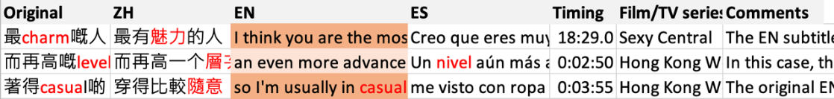
This study performed a manual comparative textual analysis to explain ‘linguistic and textual structures and their relationship with the system’ (Nord, 1991: 1), as only then can guidance be provided about the decisions ‘which the translator has to make in a particular translation process’ (ibid). Such a manual process was required due to the necessity to assess the full context were code-mixing or code-switching appeared. Only through context could this study define the adequacy and effect of specific translation strategies, especially when the data at hand was of a trilingual nature. Moreover, the section of Foreign Dialogue available in the Netflix English Timed Text Style Guide was used to comment some of the results.
Several sub-strategies inside marking and non-marking were detected for Source Language(s)-English and English-Spanish (see Table 3).
Table 3: Strategies and sub-strategies to deal with multilingualism in SL-EN and EN-ES subtitles.
SL-EN |  | EN-ES
Strategies | Sub-strategies | Strategies | Sub-strategies
Marking | Brackets | Marking | Italics
 | No subtitle |  | Quotation marks
Non-marking | Same wording | Non-marking | Spanglish
 | Reformulation
 | Active omission
Multilingual loss |  | -

Results

SL-EN direct subtitles and EN-ES indirect subtitles
Findings point towards no subtitling guidelines for the treatment of Hongkonese multilingualism by the Netflix platform. From the 350 subtitle lines collected, fewer than 20% of Cantonese to English subtitles followed a marking strategy, while a great majority of over 80% followed a non-marking strategy. In English closed captions, the main marking strategy was the use of square brackets ‘[In English]’ whenever the whole utterance was in such language (code switching). In the case of English subtitles, multilingualism was marked by not offering any subtitle during the whole duration of the utterance. In the case of English to Spanish, there were fewer than 5% cases of active marking and over 95% of non-marked multilingualism.
Language combination | Marking multilingualism | Non-marking
TL-EN | 17.7% | 82.3%
EN-ES | 2.57% | 97.43%
Sub-strategies have been ordered top to bottom according to how much they were considered to retain multilingualism (see Table 4).
Table 4: Occurrence rate of strategies and sub-strategies.
SL-EN |  | EN-ES
Strategies | Sub-strategies | Strategies | Sub-strategies
Marking | Brackets | Marking | Italics
 | No subtitle |  | Quotation marks
Non-marking | Same wording | Non-marking | Spanglish
 | Reformulation
 | Active omission
Multilingual loss |  | -

In the case of the pivot language, five sub-strategies were detected. The first, the active marking of multilingualism between brackets, was only detected in some Closed Captions (see Figure 2). However, it should be considered that the amount of English Closed Captions was lower than those of standard subtitles for the selected audiovisual creations (only Sexy Central and The Defected offered English CC).

Figure 2: Screenshot from Sexy Central (2019), chapter 1, 00:03:50, English CC.
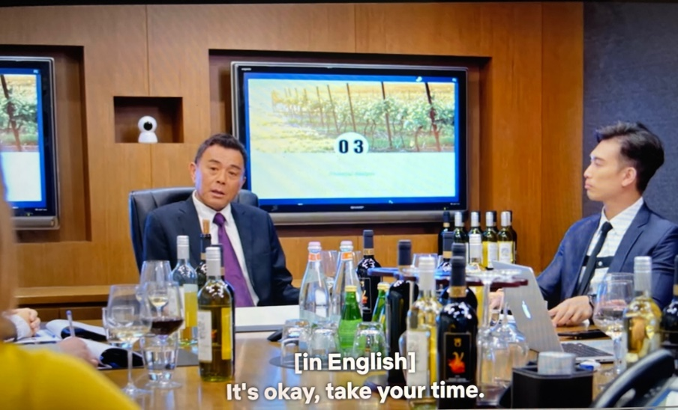
The second, also including marking, made the subtitles disappear during full English utterances (see Figure 3). The most common marking strategy according to the data obtained is not providing English subtitles for the English utterances, with a total 12.2%.
Figure 3: Screenshot from The Midas Touch (2013) 00:06:15.
From left to right, Simplified Chinese, English, and Spanish subtitles.
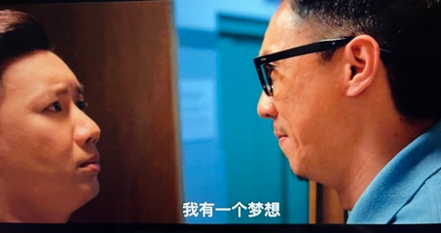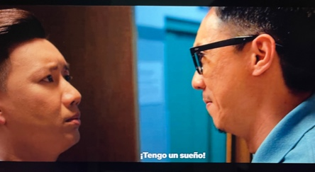
In terms of non-marking, ‘same wording’ refers to cases where the same exact word or word combination was kept in the English translation. This non-marking strategy is the most respectful toward instances of multilingualism present in original dialogues. Reformulation refers to the cases where deviations took place, in either sentence structure, terminology or both, from the original (normally code-mixed) utterance. Active omission refers to cases where the subtitler decided to completely omit the English embedded in original dialogues. Active omission was the least common sub-strategy inside non-marking strategies.
The high number of non-marking results might be motivated by two main reasons. First, English has evolved in unique ways in the Hongkonese environment. Thus, English viewers from other regions might consider subtitles that include Hong Kong English as incorrect. This might cause the rephrasing or deletion of any Konglish originally present. Indeed, a tendency was detected where English subtitles would ‘correct’ Hong Kong English. For example, the sentence ‘你明知我最憎就係social㗎啦’ (You clearly know that the thing I hate most is ‘social’) was translated as ‘you know how much I hate socializing’ (see Figure 4).
Figure 4: Screenshot from Sexy Central (2019) 00:06:05, English CC.
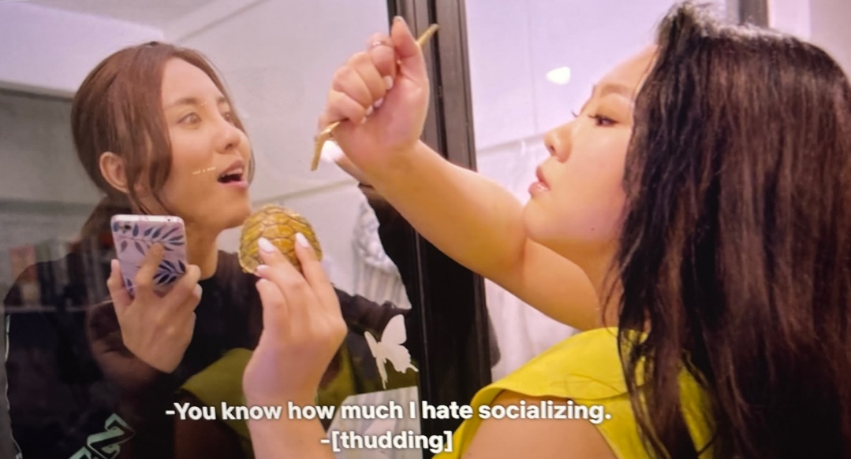
On another occasion, a singular/plural usage difference between HK English and ‘standard’ English forced the subtitler to apply changes. The original dialogue was ‘我呢兩個月不停幫你搵sponsor’ (I have been helping you find ‘sponsor’ non-stop these last two months), while the English subtitle read: ‘I’ve been looking for sponsors non-stop’.
Second, non-marking coincides with the simplification trends of subtitle creation, where space and time are scarce (Bogucki, 2004). Text reduction and simplification was detected in English and Spanish subtitles. Examples include KOL (Key Opinion Leaders) being translated as ‘celebrities’ and then as ‘celebridades’ in chapter 1 of Sexy Central or the abbreviation of post-traumatic stress disorder (PTSD) not being retained in Spanish in Chapter 2 of Sexy Central, to mention but a few. Also, certain technical words have been altered. In Sexy Central, the word ‘hit rate’ used in the original Cantonese, became ‘I am not going to change who I am for clicks’, and Spanish ensued with ‘No cambiaré por los clics’ (I won’t change for clicks).
Due to this study involving indirect translations (English to Spanish), a proper multilingualism analysis cannot be performed, as the ‘source’ text (i.e., the English subtitle) is already monolingual. It is only possible to assess the treatment of the English subtitles by Spanish translators in order to analyse variation levels from the original dialogue or to how much multilingualism is the viewer exposed via indirect subtitles (if any). In the case of Spanish subtitles, only 18 subtitle lines included signs of English. The case of proper names of places, people and brands were excluded. Neither brackets nor omission of subtitles were deployed as marking strategies. In this case, italics and quotation marks were used to mark a third language being spoken, with a total of 5 and 2 appearances respectively. There were 11 non-marked cases where English words were kept in Spanish subtitles. This non-marking was possible due to the English loanwords already present in Spanish countries, especially prevalent in Latin American variants. This inclusion only took place with terms that are commonly used or already incorporated in Spanish (i.e., selfie, show, cool, Youtuber). From these, 3 cases showed spelling adaptation (e.g., see Figure 5).
Figure 5: Screenshot from A Home with a View (2019) 00:40:21, English and Spanish.
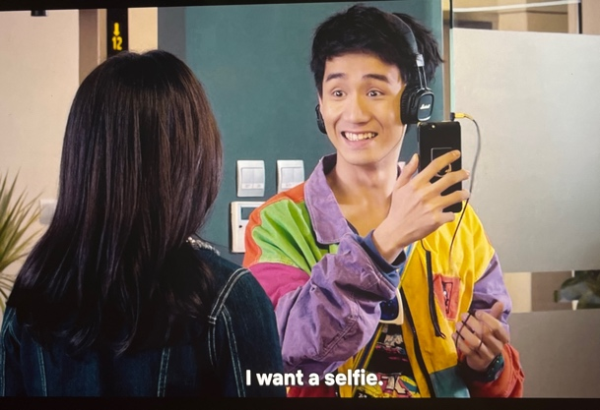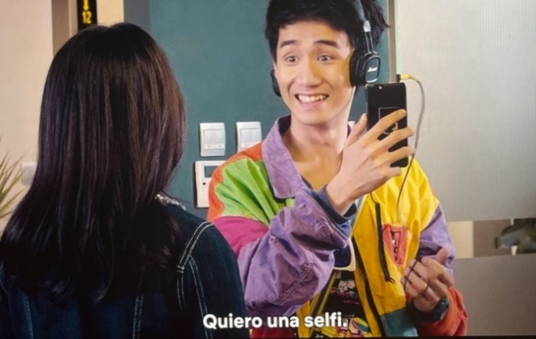
Indirect translation seems to also be affecting the translation results, including calques, uncommon formatting, or the change of proper names. Sections of foreign languages should be marked with italics when present in Spanish texts. In a relevant number of cases, Spanish subtitles followed English formatting, not marking English content. Furthermore, English subtitles include translated proper names, which in turn might be considered as original names by indirect translators. In the film Contra la Corriente, a dog originally called Doudou (豆豆) becomes ‘Beano’ in English. Spanish subtitles used the English name, failing to attach meaning to it. Indirect translation also serves as a double sieve that further erases any traces of multilingualism left. To give an example, in the film A Home with a View, the word selfie (part of the original utterance) was kept in the English subtitles, and then discarded by the Spanish translator in favour of foto (picture). This might point to the possibility that the more intermediaries are included, the weaker the final presence of multilingualism in subtitles.

Constraints and compensation strategies
Díaz Cintas (2011) argued that multilingualism tends to be hidden during audiovisual translation practices, mainly due to technical reasons and limitations, and only scarcely due to deliberate decisions. In the case of the Hongkonese creations analysed, the technical constraints involve the use of indirect translation, from Cantonese to English to Spanish, and the use of subtitles. The main linguistic constraints faced by translators were the appearance of interlanguage or code-mixing in the original dialogue, dialogues alternating Cantonese and English, and metalinguistic references, in that order of relevance.
Even explicit mentions to languages might become a possible constraint. For example, in the film The Midas Touch (2013), a Cantonese native speaker who now works as a police officer in Korea tells another Hongkonger to speak Cantonese. The Traditional Chinese subtitles read ‘說你的母語’, translated as ‘We can speak Cantonese’ and ‘Podemos hablar cantonés’ (We can speak Cantonese) respectively. Referring to the Cantonese language in the monolingual subtitles has been successfully avoided in the case of Traditional Chinese, but it is not the case in English or Spanish.
Original utterance | 咁講廣東話 (Let’s talk in Cantonese then)
Traditional Chinese | 說你的母語 (talk in your mother tongue)
English subtitles | We can speak Cantonese.
Spanish subtitles | Podemos hablar cantonés. (We can speak Cantonese)

Another example found in the film Contra la Corriente further exemplifies this loss. A man is trying to buy a music box which plays the Mandarin Chinese version of the Happy Birthday song. However, the Hong Kong store he visits only has the ‘Cantonese’ version. Then he replies, in Mandarin, that he wants the Mandarin Chinese one. The shop assistant replies in Cantonese: ‘這不就是中文嗎？祝你生日快樂…’ The English subtitle is ‘This is Chinese. Happy Birthday to You.’
Original utterance | 呢個唔係中文呀？啊, 祝你生日快樂
Traditional Chinese | 這不就是中文嗎？祝你生日快樂
English subtitles | This is Chinese. Happy Birthday to You.
Spanish subtitles | Esta es china. Feliz cumpleaños. (This one is Chinese. Happy Birthday)

When characters instantiate multilingualism through several languages or code-mixing, the contradiction of its disappearance creates non sequitur situations, and even though the use of foreign language(s) is a common comedic device in the case of Hong Kong audiovisual creations, monolingual subtitles cause a total loss of effect. In order to compensate for and avoid reception issues, it would be desirable to consistently reinforce multilingualism by marking it along the whole creation or to provide a new comedic effect altogether.
Moreover, when English texts play key roles through images, (i.e., billboards or close shots including text), this might bring multilingualism back to the spotlight. To promote viewer understanding, subtitles in full capitalization were provided in most cases, but no marking was made even when the original text was bilingual (see Figure 6).
Figure 6: Screenshot from Hong Kong West Side Stories (2018),
Chapter 3, 00:03:06, English and Spanish.
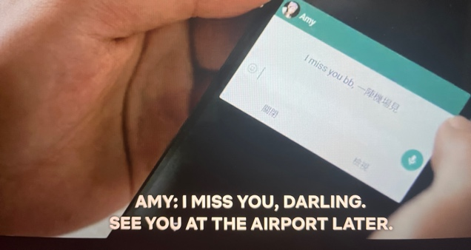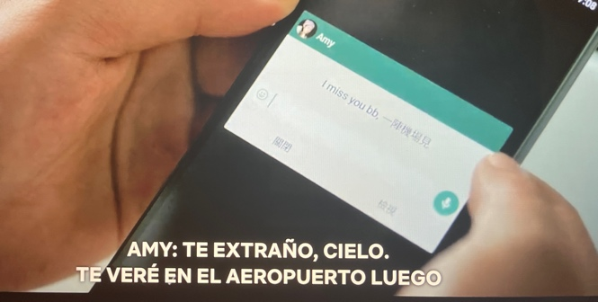
Furthermore, when anglicisms were introduced in the Spanish subtitles, italics were used to highlight them (see Figure 7). This follows Netflix’s requirement of ‘unfamiliar foreign words and phrases should be italicized’ (Netflix Partner Help Centre, 2023b). These two techniques can be promoted to help retain more traces of multilingualism.

Figure 7: Screenshot from The Midas Touch (2013), 00:56:12, English and Spanish.
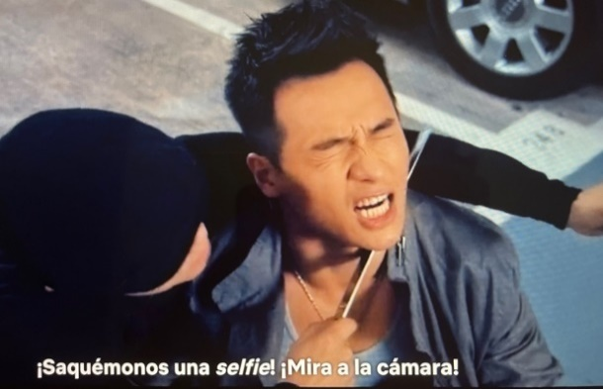
In the case of the original dialogue, English was used to achieve a range of effects, including the portrayal of status and modernity, the hinting of cultural levels, the inclusion of humour, the naming of foreign terms or concepts, etc. These fictional characters were ‘shifting between the often-opposing values of two (or three) different languages and cultures’ (Baldo, 2009: 130). Most of these nuances are lost in translation, even more when one of the source languages coincides with the target language. With the aim of retaining a certain level of multilingualism, this article proposes compensation strategies such as a better character personalization in the case of English subtitles (slang, dialects, language variants), as well as the thoughtful (re)consideration by streaming services of the strategies proposed by previous scholars.
In the case of Spanish subtitles, the use of direct translation processes is highly encouraged if a relevant amount of multilingualism is to be conveyed via subtitles. Possible strategies include retaining anglicisms from the original dialogue (whenever possible), the inclusion of language codes ([En inglés] (In English), [En chino] (In Chinese)) along subtitle content, a better character personalisation or the addition of colours for specific languages. This strategy, originating from subtitles for the deaf and hard-of-hearing, can make multilingualism be visible at a glance. Related to this, Netflix could offer Closed Captions as the standard option being these more inclusive for viewers with special needs, instead of common subtitles, to further alleviate multilingualism loss. At present, there is only a small selection of English CC for all Cantonese content, and no CC for Spanish at all. Thus, the inclusion of Closed Caption to all pieces of multilingual audiovisual content could prove beneficial.

Conclusion
Code-mixing, and to a lesser extent code-switching, are prevalent in a selection of the Hongkonese audiovisual content present on Netflix. The multilingual reality portrayed in Hongkonese audiovisual creations seems to become diluted through Netflix subtitling processes. According to preliminary data, Netflix provides no special treatment for multilingual content in the Cantonese-to-English and English-to-Spanish language combinations. These findings are in line with those of de Higes-Andino (2014), Zabalbeascoa (2020) and Savoldelli and Spiteri Miggiani (2023); multilingualism tends to become concealed in subtitled or dubbed films due to the constraints related to these translation modes. This issue might be further compounded by one of Netflix’s regulations, which states that ‘foreign dialogue should only be translated if the viewer was meant to understand it (i.e., if it was subtitled in the original version)’ (Netflix Partner Help Centre, 2023b). Moreover, findings support previous empirical studies that have shown how omission and substitution ‘are essential strategies within transcreation, localisation or adaptation, especially in AVT modes like dubbing and subtitling’ (Zabalbeascoa, 2020: 131).
The subtitling processes dilute multilingualism not only through direct translation but even more so via indirect translation. As the problem of value is central to the economics of multilingualism, the value of languages is often determined by their economic utility (Gramling, 2021). This might explain why Cantonese is indirectly translated in the case of Spanish subtitles. Indirect translation, in this case with the English language as a pivot, has caused the almost total disappearance of code-mixing, code-switching and linguistic diversity in Spanish subtitles.
However, Cantonese-English code-mixing and code-switching are vital components of Hong Kong identity, as well as of the distinctiveness of Hongkonese audiovisual creations. From a sociolinguistic and psychological standpoint, code-mixing and code-switching have both noticeable and unnoticeable effects on listeners, influencing their construction of the bilingual other (Yim & Clément, 2019: 3). The same effects and nuances are most probably not reaching foreign viewers, thus affecting their understanding, reception, and enjoyment of Hongkonese TV series and films.
Two opposing forces seem to be in collision here: multilingualism on one side, and monolingualism on the other. The translator, even though acquainted with a plurilingual reality, is shackled down by the concept of translation as the shift from one pure source language to another, equally uncorrupted, target language. Code-mixing goes against the service that the subtitler is supposed to provide to ‘monolingual’ viewers. Doing the opposite, offering code-mixed subtitles, might even help reinforce the long-held view of traduttore, traditore. By challenging the current definition of translation and subtitle quality, they risk being dismissed from employment. Multilingual audiovisual creations not only challenge but also baffle translators, who would require mastering several languages to deal with one multilingual project.
In conclusion, the concept of multilingualism seems to clash with the prevalent monolingual understanding of the translation product. Despite that, translation processes should be promoting multilingualism, not weakening its presence. We share O’Sullivan’s view that subtitles should be ‘planned from an early stage in the film’s production’ (2007: 81), especially if multilingualism is present. However, the combination of a constant supply of multimedia content that needs to be subtitled with minimal delay for maximum reach and profit and the fact that pieces of audiovisual media are subject to change until and even after release, makes such changes very difficult to implement.
Even though significant efforts are being recently put into accessibility measures (Gouleti, 2023), more attention should be also paid to catering to language variant users and multilingual audiences. Code-mixing subtitles, subtitles including a mix of two or more languages for any line of dialogue, could be considered as a tool to accurately portray the reality we live in. However, the use of code-mixing subtitles is expected to face rejection at first. Lee (2021) explored the reception of code-mixing subtitles in Singapore, finding that ‘the majority of the respondents preferred subtitles to be expressed in standard language’ (p. 2). Notwithstanding this fact, the author also found that there was ‘a minority who preferred code-mixing subtitles’ (ibid) to preserve national identity, hinting that there might be room for such an approach.
The present article assessed the treatment of multilingualism on the Netflix platform, finding several issues and exploring various translation strategies relevant to multilingualism. This piece of research is of an introductory nature and further explorations are required to accurately ascertain this complex phenomenon. Future studies could explore in more depth the translational treatment of Hongkonese multilingualism by compiling more extensive databases or by covering new topics, such as an exploration of subtitling decisions and processes via interviews and questionnaires to subtitlers, or the reception of Hongkonese multilingualism (specifically code-mixing and code-switching) via subtitles in English and Spanish-speaking markets.

Caveat
All images included in this article are used solely for the purposes of academic quotation, criticism and review. Additionally, where appropriate, the author has sought permission for their inclusion in this article. All rights in these images are retained by their respective copyright owners and any citations to them should be to the original sources as listed.
Luis Damián Moreno García, PhD, is an assistant professor at Hong Kong Baptist University, a Chinese-Spanish freelance translator and interpreter specialized in film subtitling and video game localization, and an English-Spanish sworn translator. His research interests lie in the fields of software localization, translation technologies and audiovisual translation involving Chinese, English and Spanish as linguistic combinations. His research has been published in journals such as Translation, Cognition & Behaviour, Translation Spaces and Babel, as well as in edited volumes by Routledge and Palgrave Macmillan.

List of Tables
Table 1: Percentage of Hongkonese content on Netflix according to release year periods.
Table 2: Hongkonese TV series and films chosen as case studies.
Table 3: Strategies and sub-strategies to deal with multilingualism in SL-EN and EN-ES subtitles.
Table 4: Occurrence rate of strategies and sub-strategies.

List of Figures
Figure 1: Screenshot of the Chinese-English-Spanish database.
Figure 2: Screenshot from Sexy Central (2019), chapter 1, 00:03:50, English CC.
Figure 3: Screenshot from The Midas Touch (2013) 00:06:15. From left to right, Simplified Chinese, English, and Spanish subtitles.
Figure 4: Screenshot from Sexy Central (2019) 00:06:05, English CC.
Figure 5: Screenshot from A Home with a View (2019) 00:40:21, English and Spanish.
Figure 6: Screenshot from Hong Kong West Side Stories (2018), Chapter 3, 00:03:06, English and Spanish.
Figure 7: Screenshot from The Midas Touch (2013), 00:56:12, English and Spanish.

References
Appel, R. and Muysken, P., 2006. Language Contact and Bilingualism. Amsterdam: University Press. DOI: 10.1075/jpcl.6.2.15dis [Accessed: 25 March 2024].
Ávila-Cabrera, J., 2013. Subtitling multilingual films: The case of Inglourious Basterds. RAEL: Revista Electrónica de Lingüística Aplicada [E-Journal of Applied Linguistics], 12, pp. 87-100.
Bacon-Shone, J. and Bolton, K., 2008. Bilingualism and multilingualism in the HKSAR: Language surveys and Hong Kong's changing linguistic profile. In: Bolton, K. and Han, Y., eds., Language and society in Hong Kong. Hong Kong, China: Hong Kong Open University Press, pp. 25-51.
Baldo, M., 2009. Subtitling Multilingual Films. The case of Lives of the Saints, an Italian-Canadian TV Screenplay. In: Federici, F., ed., Translating Regionalised Voices in Audiovisuals. Rome, Italy: Aracne Editrice, pp. 117-135.
Bartoll, E., 2006. Subtitling multilingual films. Proceedings of the Marie Curie Euroconferences MuTra: Audiovisual Translation Scenarios, 1-5 May 2006, Copenhagen. Available at: https://www.euroconferences.info/proceedings/2006_Proceedings/2006_Bartoll_Eduard.pdf [Accessed: 25 March 2024].
Beseghi, M., 2017. Multilingual Films in Translation. Oxford, UK: Peter Lang Verlag. DOI: 10.3726/b13099 [Accessed: 25 March 2024].
Bogucki, Ł., 2004. The constraint of relevance in subtitling. The Journal of Specialised Translation, 1(Jan).
Bolton, K., 2002. Hong Kong English: Autonomy and creativity. Hong Kong, China: Hong Kong University Press.
Bolton, K., 2003. Chinese Englishes: A sociolinguistic history. Cambridge, UK: Cambridge University Press.
Bolton, K., Bacon-Shone, J. and Kwong Luke, K., 2020. Hong Kong English. In: Bolton, K., Botha, W. and Kirkpatrick, A., eds., The Handbook of Asian Englishes. Oxford/New Jersey: Wiley-Blackwell, pp. 449-478.
Chan, B. H. S., 2009. English in Hong Kong Cantopop. World Englishes 28(1), pp. 107-129.
Chen, K. H. Y., 2008. Positioning and repositioning: linguistic practices and identity negotiation of overseas returning bilinguals in Hong Kong. Multilingua, 27(1/2), pp. 57-75.
Cheung, C., 2020. Hidden Hong Kong: A history of Hong Kong cinema through the ages. Localiiz. Available at: https://www.localiiz.com/post/culture-cinema-history-hong-kong-movies-through-the-ages [Accessed: 24 March, 2024].

Corrius, M., Espasa, E. and Zabalbeascoa, P., 2019. The Multilingual Text: A Challenge for Audio Description. In: Corrius, M., Espasa, E. and Zabalbeascoa, P., eds., Translating Audiovisuals in a Kaleidoscope of Languages. New York: Peter Lang, pp. 147-171.
Corrius, M. and Zabalbeascoa, P., 2011. Language variation in source texts and their translations: The case of L3 in film translation. Target-international Journal of Translation Studies, 23(1), pp. 113-130.
Corrius, M. and Zabalbeascoa, P., 2019. Translating code-switching on the screen: Spanglish and L3-as-theme. Journal of Audiovisual Translation, 2(2), pp. 72-91.
de Higes-Andino, I., Prats-Rodríguez, A. M., Martínez-Sierra, J. J. and Chaume, F., 2013. Subtitling Language Diversity in Spanish Immigration Films. Meta, 58(1), pp. 134-145. DOI: https://doi.org/10.7202/1023813ar [Accessed: 25 March 2024].
de Higes-Andino, I., 2014. The translation of multilingual films: Modes, strategies, constraints and manipulation in the Spanish translations of It’s a Free World. Linguistica Antverpiensia, New Series. Themes in Translation Studies, 13, pp. 211-231. DOI https://doi.org/10.52034/lanstts.v13i.47 [Accessed: 25 March 2024].
Díaz-Cintas, J., 2011. Dealing with multilingual films in audiovisual translation. In: Pöckl, W., Ohnheiser, I. and Sandrini, P., eds., Translation-Sprachvariation-Mehrsprachigkeit. Festschrift für Lew Zybatow zum 60. Geburtstag. Frankfurt am Main: Peter Lang, pp. 215-233.
Fan, V., 2023. Code-mixing and code-switching in classical Hong Kong cinemas. Concentric: Literary and Cultural Studies, 49(1), pp. 27-47.
Gibbons, J., 1983. Attitudes towards languages and code-mixing in Hong Kong. Journal of Multilingual and Multicultural Development, 4(2-3), pp. 129-147.
Giustini, D., 2022. The language industry, automation, and the price of finding the right words. Futures of Work, 21, pp. 1-9.
Gogolin, I., 2021. Multilingualism: A threat to public education or a resource in public education? - European histories and realities. European Educational Research Journal, 20(3), pp. 297-310. DOI: : 10.1177/1474904120981507 [Accessed: 25 March 2024].
Gouleti, K., 2023. Bilingual subtitling in streaming media: Pedagogical implications. Target International Journal of Translation Studies, 35(3), pp. 354-377. DOI: 10.1075/target.00013.gou [Accessed: 25 March 2024].
Gramling, D. (2021). The Invention of Multilingualism. United Kingdom: Cambridge University Press. DOI: 10.1017/9781108780667 [Accessed: 25 March 2024].
Grutman, R., 2009. Multilingualism. In: Baker, M. and Saldana, G., eds., Routledge Encyclopedia of Translation Studies. London and New York: Routledge, pp. 182-186.
HKSAR Gov., 2016. Summary Results of 2016 Population By-Census. Available at https://www.bycensus2016.gov.hk/en/ [Accessed: 25 March 2024].
HKSAR Gov., 2022. Use of Language by Hong Kong Population. Available at: https://www.census2021.gov.hk/doc/pub/21C_Articles_Use_of_Language.pdf [Accessed: 25 March 2024].
Jenner, M., 2018. The transnational and domestication: Netflix texts. In: Jenner, M., ed., Netflix and the Re-invention of Television. Cham, Switzerland: Palgrave Macmillan, pp. 219-240. DOI: 10.1007/978-3-319-94316-9_12 [Accessed: 25 March 2024].
Ju, H., 2019. Korean TV drama viewership on Netflix: Transcultural affection, romance, and identities. Journal of International and Intercultural Communication, 13, pp. 32-48. DOI: 10.1080/17513057.2019.1606269 [Accessed: 25 March 2024].
Kuosmanen, J., 2020. Getting Your Daily Flix: A Reception Study of Netflix and Its Subtitles. M.A. Dissertation, University of Eastern Finland, Joensuu/Kuopio. Available at: https://erepo.uef.fi/handle/123456789/24003 [Accessed: 25 March 2024].
Kuscu-Ozbudak, S., 2021. The role of subtitling on Netflix: An audience study. Perspectives, pp. 1-15. DOI: 10.1080/0907676x.2020.1854794 [Accessed: 25 March 2024].
Labarta Postigo, M., 2021. Multilingual Translation of English Idioms in Internet-based TV series: A Contrastive Approach. L2 Journal, 13(1), pp. 1-19. DOI: 10.5070/l213149027 [Accessed: 25 March 2024].
Lee, C. K.M., 2007. Linguistic features of email and ICQ instant messaging in Hong Kong. In: Danet, B. and Herring, S. C., eds., The Multilingual Internet: Language, Communication and Culture Online. New York: Oxford University Press, pp. 184-208.
Lee, W. L., 2021. A study of audience reception on code-mixing in subtitles: Singapore dreaming as an example. M.A. Dissertation, Nanyang Technological University, Singapore.
Li, D. C. S., 2017. Multilingual Hong Kong: Languages, Literacies and Identities. New York, USA: Springer.
Li, D.C.S., 2022. Trilingual and biliterate language education policy in Hong Kong: Past, present and future. Asian-Pacific Journal of Second and Foreign Language Education, 7(41). DOI: 10.1186/s40862-022-00168-z [Accessed: 25 March 2024].
Lixun, W., 2019. Code-switching and code-mixing in trilingual education in Hong Kong: A case study. PUPIL: International Journal of Teaching, Education and Learning, 3(2), pp. 124-139.
Lobato, R., 2019. Netflix Nations: The Geography of Digital Distribution. New York, USA: New York University Press. DOI: 10.18574/9781479882281 [Accessed: 25 March 2024].
Martínez-Sierra, J. J., Martí-Ferriol, J. L., de Higes-Andino, I., Prats-Rodríguez, A. and Chaume, F., 2010. Linguistic diversity in Spanish immigration films: A translational approach. In: Berger, V. and Komori, M., eds., Polyglot cinema: Migration and transcultural narration in France, Italy, Portugal and Spain. Vienna: LIT, pp. 15-32.
Meylaerts, R., 2013. Multilingualism as a challenge for translation studies. In: Millán, C. and Bartrina. F., eds., The Routledge Handbook of Translation Studies. London and New York: Routledge, pp. 1298-1334. DOI: 10.4324/9780203102893-50 [Accessed: 25 March 2024].
Meylaerts, R. and Şerban, A., 2014. Introduction. Multilingualism at the cinema and on stage: A translation perspective. Linguistica Antverpiensia, New Series. Themes in Translation Studies, 13, pp. 1-13. DOI: 10.52034/lanstts.v13i [Accessed: 1 February 2022].
Molina, L. and Hurtado Albir, A., 2002. Translation techniques revisited: A dynamic and functionalist approach. Meta: Journal des traducteurs, 47(4), pp. 498-512. DOI: 10.7202/008033ar [Accessed: 5 February 2022].
Netflix, 2022. Company Profile. Available at: https://ir.netflix.net/ir-overview/profile/default.aspx [Accessed: 25 March 2024].
Netflix HK-EN, 2023. Sexy Central. Available at: https://www.netflix.com/hk-en/TITLE/81144516 [Accessed: 25 March 2024].
Netflix Partner Help Center, 2023a. Timed Text Style Guide: General Requirements. Available at: https://partnerhelp.netflixstudios.com/hc/en-us/articles/215758617-Timed-Text-Style-Guide-General-Requirements [Accessed: 25 March 2024].
Netflix Partner Help Center, 2023b. English Timed Text Style Guide. Available at: https://partnerhelp.netflixstudios.com/hc/en-us/articles/217350977-English-Timed-Text-Style-Guide [Accessed: 25 March 2024].
Nord, C., 1991. Text analysis in translation: Theory, methodology, and didactic application of a model for translation-oriented text analysis. Amsterdam: Rodopi. DOI: 10.1163/9789004500914 [Accessed: 25 March 2024].
O'Sullivan, C., 2007. Multilingualism at the multiplex: A new audience for screen translation?. Linguistica Antverpiensia, 6, pp. 81-95.
Pedersen, J., 2018. From old tricks to Netflix: How local are interlingual subtitling norms for streamed television? Journal of Audiovisual Translation, 1(1), pp. 81-100. DOI: 10.47476/jat.v1i1.46 [Accessed: 25 March 2024].

Ponkala, M., 2018. Quality of Subtitling in Online Streaming Subscription Services. A comparative study on subtitling quality between Netflix Original episodes and previously aired episodes of Gilmore Girls on Netflix. M.A. Dissertation, University of Eastern Finland, Joensuu/Kuopio. Available at: https://erepo.uef.fi/handle/123456789/19720 [Accessed: 25 March 2024].
Sánchez-Mompeán, S., 2021. Netflix likes it dubbed: Taking on the challenge of dubbing into English. Language & Communication, 80, pp. 180-190. DOI: 10.1016/j.langcom.2021.07.001 [Accessed: 25 March 2024].
Savoldelli S., and Spiteri Miggiani G., 2023. The rendering of multilingual occurrences in Netflix’s Italian dub streams: Evolving trends and norms on streaming platforms. Languages, 8(2), pp. 113-135.
Setter, J., Wong, C. S. P., and Chan, Brian H. S., 2010. Hong Kong English. Edinburgh University Press.
Shi, Y., and Zhou, J., 2021. Analysis of foreign video streaming service entering Chinese streaming media market: A case study of Netflix. In: Proceedings of the 2021 International Conference on Public Relations and Social Sciences. Kunming, China.
Szarkowska, A., Żbikowska, J. and Krejtz, I., 2013. Subtitling for the deaf and hard of hearing in multilingual films. International Journal of Multilingualism, 10, pp. 292-312. DOI: 10.1080/14790718.2013.766195 [Accessed: 25 March 2024].
Voellmer, E., 2012. ‘Excuse me, but your accent is very unusual. The complexity of establishing third languages in ‘Inglourious Basterds’. Applying a model of translation analysis to dubbing. M.A. Dissertation, unpublished, Universitat Pompeu Fabra, Barcelona.
Yau, M. S., 1993. Functions of the two codes in Hong Kong Chinese. World Englishes, 12(1), pp. 25-33.
Yim, O. and Clément, R., 2019. “You’re a Juksing”: Examining Cantonese–English code-switching as an index of identity. Journal of Language and Social Psychology, 38(4), pp. 479-495. DOI: 10.1177/0261927X19865572 [Accessed: 25 March 2024].
Zabalbeascoa, P., 2020. Multilingual humour in audiovisual translation. In: Dore, M., ed., Humour Translation in the Age of Multimedia. London and New York: Routledge, pp. 116-135.

To cite this article:
Moreno García, L.D., 2024. Subtitling Hong Kong code-mixing and code-switching: the case of Netflix English and Spanish official subtitles for Hongkonese audiovisual creations. Exchanges: The Interdisciplinary Research Journal, 11(2), 161-187. Available at: https://doi.org/10.31273/eirj.v11i2.1155.

